MM_SUM

SELECT `MARKET_ID`, `MARKET_N` FROM `KNTR_market` WHERE `MARKET_ID` IN (SELECT DISTINCT KNTR_MM_SUM.MARKET_ID FROM KNTR_MM_SUM WHERE OPRODUCT_ID =34154274)

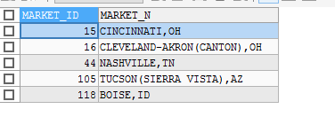

`MarketAdvertiser_P`.`K_Ad_Sum_InfaRMbridge` Ads

WHERE `kantar_advertiser` = 'Alabama Black Belt Adventures'

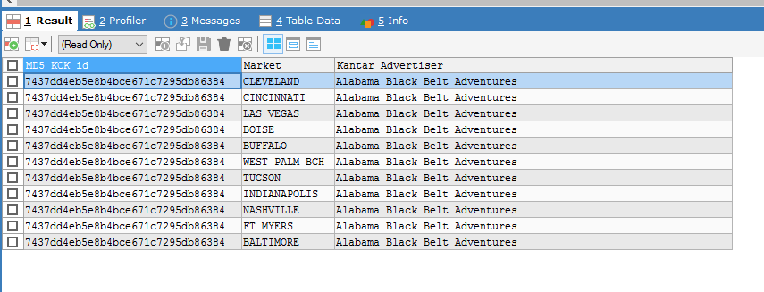

SELECT DISTINCT `kantar advertiser`, market FROM `MarketAdvertiser_P`.`vw_mv_K_AdSum_Mkt_OwnTag_BHL_Mkt_unq_Infa` WHERE `kantar advertiser`= 'Alabama Black Belt Adventures'

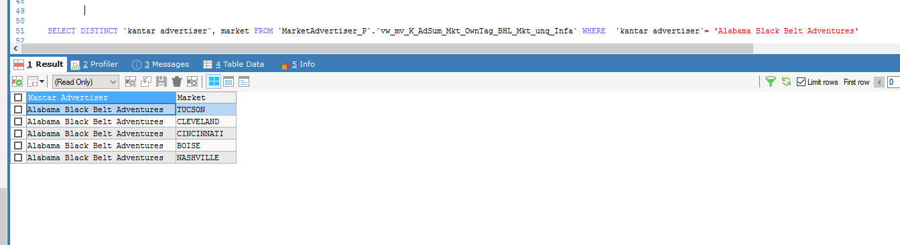

SELECT DISTINCT

MD5(UPPER(Ads.KConcatKey)) AS MD5_KCK_id,

Ads.Market,

Ads.`Kantar_Advertiser`

-- ,

-- Ads.`Kantar_Brand`,

-- Ads.`Kantar_Product`,

-- Ads.`Kantar_Industry_Name`,

-- Ads.`Kantar_Category_Name`,

-- Ads.`Kantar_Major_Group_Name`,

-- Ads.`Property_Owner`,

-- Ads.PROPERTY,

-- Ads.`TIME_PERIOD`,

-- Ads.Media,

-- Ads.DOLS,

-- Ads.UNITS

FROM `MarketAdvertiser_P`.`K_Ad_Sum_InfaRMbridge` Ads

WHERE `kantar_advertiser` = 'Alabama Black Belt Adventures'

SELECT DISTINCT marketNm, oproductId FROM `eaStgKntr`.`wrkAdSummaryJNproductHierarchy` WHERE `productHierarchyMd5pk`='D73183EE9C1CC6275F29A06F4B27C937'

SELECT DISTINCT oproductId, Market FROM `eaStgKntr`.wrkVwCurOproductAdSummary

-- inner join `eaStgKntr`.LkpKantarMedia on wrkVwCurOproductAdSummary.mediaId=LkpKantarMedia.mediaId

WHERE oproductId=34154274

SELECT DISTINCT a.marketId, a.marketNm, b.oproductMd5pk, b.marketId

FROM `eaMarketAdvertiser`.`vwCurRefMarket` a JOIN `eaRlnKntr`.`satOproductAdSummary` b

ON a.`marketId`= b.`marketId`

WHERE oproductMd5pk='D73183EE9C1CC6275F29A06F4B27C937'

WHERE `marketId` IN (

SELECT DISTINCT marketId FROM `eaRlnKntr`.`satOproductAdSummary` `sat` WHERE oproductMd5pk='D73183EE9C1CC6275F29A06F4B27C937')

LEFT JOIN `eaRlnKntr`.`hubOproduct` `hub`

ON ((`sat`.`oproductMd5pk` = `hub`.`oproductMd5pk`)

SELECT * FROM `eaRlnKntr`.`hubOproduct` WHERE oproductId=34154274

oproductMd5pk='D73183EE9C1CC6275F29A06F4B27C937'

SELECT DISTINCT KNTR_MM_SUM.OPRODUCT_ID, KNTR_MM_SUM.MEDIA_ID, KNTR_MM_SUM.PROPERTY_ID, KNTR_MM_SUM.MARKET_ID, KNTR_MM_SUM._DATE, KNTR_MM_SUM.CALENDAR_MONTH,

KNTR_MM_SUM.COST_V, KNTR_MM_SUM.UNITS_V, KNTR_MM_SUM.BATCH_ID, KNTR_MM_SUM.RECORD_ID, KNTR_MM_SUM.STATUS_CD

FROM KNTR_MM_SUM WHERE OPRODUCT_ID =34154274

SELECT `OPRODUCT_ID`,`PRODUCT_ID` FROM `KNTR_oproduct` WHERE `OPRODUCT_ID`=34154274

SELECT `PRODUCT_ID`, `ADVERTISER_ID`, `PRODUCT_NAME_ID` FROM `KNTR_product` WHERE `PRODUCT_ID`=34154274

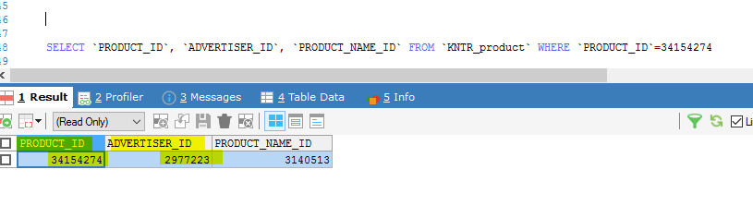

SELECT `ADVERTISER_ID`, `ADVERTISER_N` FROM `KNTR_advertiser` WHERE `ADVERTISER_ID`=2977223

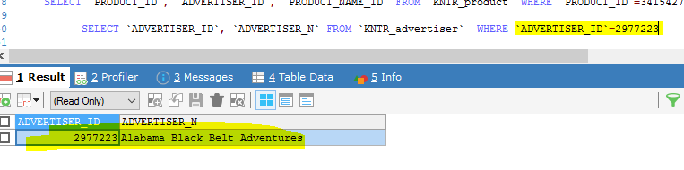

SELECT `MARKET_ID`, `MARKET_N` FROM `KNTR_market` WHERE `MARKET_ID` IN (SELECT DISTINCT KNTR_MM_SUM.MARKET_ID FROM KNTR_MM_SUM WHERE OPRODUCT_ID =34154274)

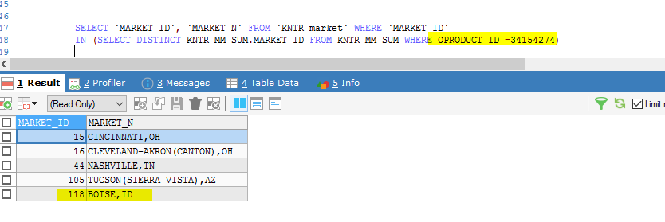

SELECT DISTINCT -- t1.oproductMd5pk,t1.productHierarchyMd5pk,t2.productHierarchyMd5pk,

t1.oproductId,t1.propertyId,t1.marketId,t1.marketNm,t2.advertiserId,t2.advertiserNm,

t2.productId

FROM wrkAdSummaryJNproductHierarchy t1 LEFT OUTER JOIN wrkProdHierJNcategory t2

ON t1.productHierarchyMd5pk = t2.productHierarchyMd5pk

WHERE t2.productId = 34154274

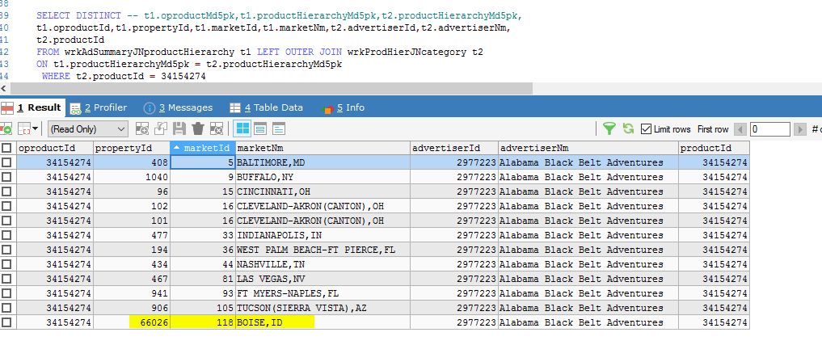

SELECT t1.oproductMd5pk,t1.productHierarchyMd5pk,t1.propertyId,t1.marketId,t1.marketNm,t1.oproductId,

t2.productHierarchyMd5pk,t2.productId,t2.advertiserId,t2.advertiserNm

FROM wrkAdSummaryJNproductHierarchy t1 LEFT OUTER JOIN wrkProdHierJNcategory t2

ON t1.productHierarchyMd5pk = t2.productHierarchyMd5pk

WHERE t2.productId = 34154274

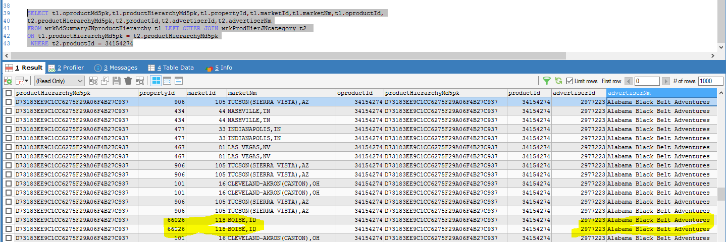

SELECT * FROM `MarketAdvertiser_P`.K_Advertiser_Ownership_Tags_MKT_Infa

WHERE `Kantar_Advertiser`='Alabama Black Belt Adventures'

